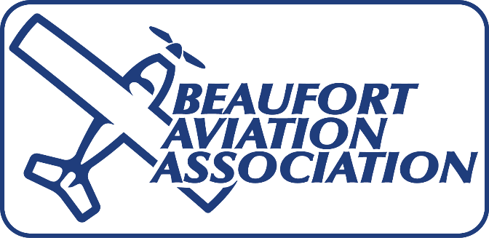
THE MAGIC OF FLIGHT
What is an aircraft? -Anything that navigates through the air under the control of a human being. -Aircraft may be heavier or lighter than air.
Uses and types of aircraft -Commercial airliners - Air cargo carriers - Military supply transports - Military fighters and bombers - Rotary wing helicopters - General aviation pleasure flying - Hot air balloons - Balloons for exploration of the upper atmosphere - Weather balloons - Water floatplanes and seaplanes - Farm crop dusting - Firefighting
How an airplane flies Four forces which act upon the airplane in flight -Lift –-An upward acting force –-Bernoulli: In the 1700s, found that the pressure of any fluid decreases at points where the speed of the fluid increases. -–Airfoil: A curved top surface and flat bottom surface that causes the air moving over the upper surface to travel faster than the air moving over the bottom surface. Faster moving air causes lower pressure on the top surface, producing lift. -Weight –-A downward acting force –-How does gravity or weight affect you? If you don’t make an effort to stand up, will you fall down because the force of gravity will pull you toward the ground?

-Thrust -–A forward acting force -–Produced by a motor driven propeller, jet engine, turbine driven propeller or rocket. -Drag –-A backward acting force –Pedaling a bicycle into a strong wind is easier if you lean over the handle bars. --Thrust and lift forces act together to counteract the forces of weight and drag --Angle of incidence or angle of attack: The angle at which the wing meets the relative wind. -The greater the angle, the more lift and drag created up to a certain point called the critical angle. -At the critical angle, usually 18-20 degrees, the air cannot flow smoothly over the wing’s upper surface. The air flow separates from the surface and the flow immediately becomes turbulent. Lift ceases to exist at this point and the wing is said to have “stalled”.
Flying an Airplane Pilot controls the plane by increasing or decreasing the power and by moving the five airfoils –When the airfoils or surfaces are moved the flow of air over them is changed and the resulting force changes the position, or attitude of the surface to the relative wind. –The two ailerons and the elevators are connected to a wheel or stick in the cockpit. Foot pedals control the rudder and a throttle controls the power of the engine which increases or decreases the thrust. –Control stick or wheel can be moved in all directions. As it its moved, it changes the position of the ailerons and elevators. –When the wheel is rotated or the stick is moved to the right, the left aileron goes down and the right aileron goes up so the plane rolls right. –When the wheel or stick is moved forward, the elevators move downward increasing the lift of the tail and forcing the tail upward so the nose of the plane moves downward. “Push forward and the houses get bigger; pull back and they get smaller.” Maneuvering the plane -Takeoff: When flying speed is reached, ease back on the wheel or stick to raise the nose. -Straight climb: Ease back on the wheel or stick to raise the nose. -Level turn: Turn the wheel or stick toward the direction you want to turn and add a little pressure on the rudder pedal on the side you wish to turn. -Climbing turn: The control movements combine the movements necessary for a straight climb and a level turn. -Straight descent: Push forward on the wheel or stick to lower the nose. -Descending turn: The control movements combine the movements necessary for a straight descent and a level turn. –Landing: Use a straight descent to the runway, then, when a few feet over it, ease back on the wheel or stick until the wing stalls and you touch down.
Flying instruments -Altimeter shows the altitude above sea level and works by measuring air pressure -Airspeed indicator shows the plane’s speed through the air and works by measuring air pressure. -Compass shows the magnetic direction the nose is pointing. -Turn and bank indicator shows the rate of the turn when the plane is in a bank and the ball indicates if the plane is in coordinated flight. -Engine tachometer measures engine revolutions to show power applied. -Oil pressure gauge measures liquid pressure in the engine. -Oil temperature gauge shows temperature in the engine. -Navigation displays or instruments -Radios and position transponders
Safety on the ground and around the airport -When you visit an airport, remember that you are there as a guest. -Special dangers --Keep well away from propellers --Always walk behind a propeller-driven plane and in front of a helicopter --Keep away from jet intakes and exhausts -–Obey all warning signs --Keep off taxiways and runways

